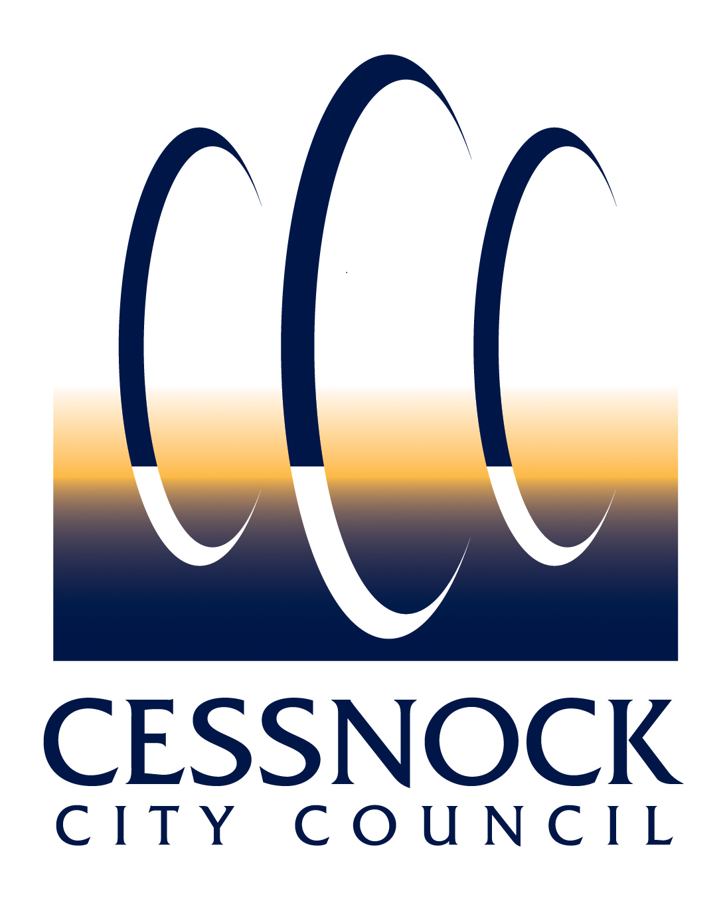 |  |  | OPEN SPACE AND COMMUNITY FACILITIES  APPLICATION FOR MASTER LOCKSMITHS ASSOCIATION KEY (MLAK) |  |  |  |  |  |  | OFFICE USE ONLY
 |  |  | Place stamp here (Office use) |  |  |  |  |  |  | Date ______________  Key No ____________  W01514.0001.0270  Receipt No _________
P A R T 1 – A P P L I C A T I O N D E T A I L S
INFORMATION FOR APPLICANT
The Master Locksmiths Association Key (MLAK) is a specifically designed key enabling people with a disability to access community facilities throughout New South Wales. Within the Cessnock area the MLAK provides access to the Liberty swing and amenities within Peace Park, Weston, as well as public amenities containing the MLAK lock such as the Council Administration Building.
APPLICANT DETAILS
Name
Postal Address |  |  |  |  |  |  |  | Telephone
Suburb |  |  |  |  |  | State |  | Postcode Mobile
Email
P A R T 2 – E L I G I B I L I T Y
ELIGIBILITY CRITERIA
To purchase an MLAK from Council, applicants must provide one of the following:
 | A letter from a doctor
 | A current Roads and Maritime Service mobility parking scheme permit
 | A letter from a disability organisation or community health centre
 | A disability card
P A R T 3 – A C C E P T A N C E O F M L A K
APPLICANT DECLARATION
I am applying for an MLAK to access community facilities as described in this application. I declare that all the information in the application is, to the best of my knowledge, true and correct.

I give consent to Cessnock City Council to use the application and documents, provided in support of this application for advertising and notification purposes.

I have read the eligibility criteria for the issue of an MLAK. I agree to abide by and be bound by those conditions.
Applicant Name |  |  |  |  |  |  | Date
Applicant Signature
PRIVACY DISCLOSURE
Council is subject to the Privacy and Personal Information Protection Act 1998 (NSW) in dealing with your personal information. Council's Privacy Management Plan and Privacy Statement describe how the agency meets these obligations
Purpose |  |  |  | The information on this application for master locksmiths association key is being collected for the purpose of processing the application form.
Intended Recipients |  |  |  | Cessnock City Council
Supply |  |  |  | Voluntary
Consequence of  Non-provision |  |  |  | If you do not supply the information, we will not be able to process your application.
Storage and Security |  |  |  | Your personal information will be kept in Council's Information Management System in  accordance with the relevant legislation. Council's address is 62-78 Vincent Street CESSNOCK NSW 2325
Access |  |  |  | You may access, correct or update your personal information by visiting Council's website, contacting Council's Privacy Contact Officer on 4943 4100 or by sending an email to council@cessnock.nsw.gov.au .
PART 4 - LODGEMENT INFORMATION
HOW TO LODGE YOUR APPLICATION
Address the application to  General Manager  Cessnock City Council  PO Box 152  CESSNOCK NSW 2325 |  |  |  |  | Lodge in person  (between 9am – 4.30pm) at Council’s Administration Building  Cessnock City Council  62-78 Vincent Street  CESSNOCK NSW  Lodge by email  council@cessnock.nsw.gov.au  Payment Method  In person - Cash, Cheque, Money Order, Bankcard, Mastercard, Visa, and/or EFTPOS. |  |  |  | How to Contact Us  Phone: (02) 4993 4100  Email:council@cessnock.nsw.gov.au  www.cessnock.nsw.gov.au  Office Hours  9am to 5pm Monday to Friday  *Payments are accepted until 4.30pm  Fees  Fees are calculated in accordance with Council’s adopted fees and charges.
If you require further information regarding this request, please contact Council’s Customer Service on (02) 4993 4100.

